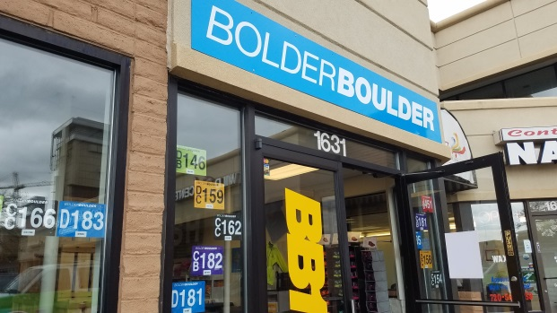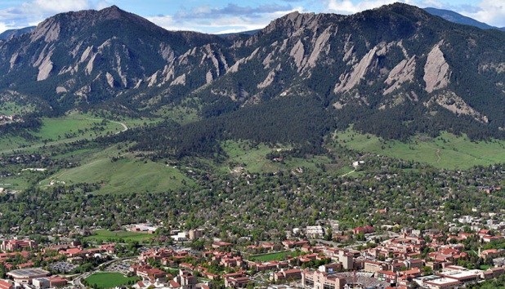
Training Details
- 12 Week Training Program…2 weeks Base and 10 weeks of Group Workouts (Mar 5th thru May 28th)
- Training begins the week of Mar 5th (schedule posted on front page of website).
- FIRST MEETING – Wed Mar 7th
- There will be 2 Training Groups BASED on MEETING times: morning and evening with all abilities welcome
  - evening meets Wed @ 5:30 pm and Sat @ 7:30 am
  - morning meets Wed @ 6:30 am and Sat @ 7:30 am
- Train with other Boulder Strider Members at your goal pace in a non-intimidating fun atmosphere
- Bring a NEW Friend to Join Boulder Striders and you BOTH get $25 off your registration fee
Boulder Striders’ Program Rates
Early Bird Special Pay by Mar 5th (NO Exceptions) | $275  $250 | Twice/week - 2 weeks base / 10 weeks of twice a week training  Once/week – 2 weeks base/ 10 weeks of once a week training
Regular Price  Starts Mar 6th | $300  $275 | Twice/week - 2 weeks base / 10 weeks of twice a week training  Once/week – 2 weeks base/ 10 weeks of once a week training
MAKE CHECKS PAYABLE TO: BOULDER STRIDERS
OR CREDIT CARD...ADD $11 TO THE PROGRAM RATE
Please Print & Mail Registration (postmarked Mar 5th to get early bird…NO exceptions) to:
Boulder Striders, 4162 Saint Croix St, Boulder, CO 80301
2018 Spring Registration Form
Last Name |  |  |  |  | First Name
Address
City |  |  |  | State |  |  |  |  |  | Zip
DOB |  |  | Email
Day Phone
 | Evening: Wed/Sat (5:30 pm /7:30 am ) |  |  |  |  |  | Morning: Wed/Sat (6:30 am / 7:30 am )

By signing this Registration Form, I do not hold Colleen De Reuck, Boulder Striders or any of the Coaches liable for injury to myself during the 12 week training. One Form per Member…Photocopies are good.

Signature: __________________________________________

